Chapter 15, Solution 53.

Transform each term.

We begin by noting that the integral term can be rewritten as,

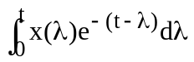 which is convolution and can be written as e^{–t}*x(t).

Now, transforming each term produces,

X(s) = 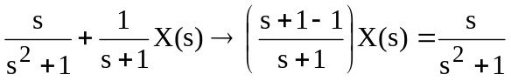

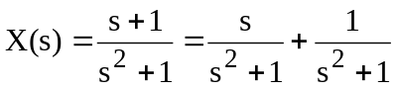

x(t) = cos(t) + sin(t).

If partial fraction expansion is used we obtain,

x(t) = 1.4142cos(t–45˚).

This is the same answer and can be proven by using trigonometric identities.

